**UNIVERSITY OF SUNDERLAND**

**ASSESSMENT COVER SHEET / FEEDBACK FORM**

**MBA**

Student Name: Ma Pengcheng

Student ID: SCKL2102006

Module Code: PGBM150

Module Name: Innovation, Entrepreneurship & Technology Transfer

Centre / College: SEGi College, Kuala Lumpur

Hand in Date:24/04/2022

Due Date: 28/04/2022

Assessment Title: Individual Assignment

Learning Outcomes Assessed:

Learning Outcomes Assessed:

Mark:

Feedback relating learning outcomes assessed and assessment criteria given to students:

Areas for Commendation:

Areas for Improvement:

General Comments:

Moderators Signature:

Overall Mark (subject to ratification by the assessment board)

Assessors Signature:

Students Signature: Ma Pengcheng

**Abstract**

This research objectifies the importance of 5-G technology implementation which underlines the efficiency of consumers' services and virtual workplace environment of ***Clicktrue Group***. The sections are divided into a literature review where the importance and benefits of 5-G networks in the virtual workplace environment are highlighted. Moreover, the section on methodology has outlined the preferences of quantitative and qualitative data collection.

**Table of Contents**

A. Introduction on technology innovation 5

B. Literature Review about the overview of the company 5

Overview of Clicktrue Group 5

Overview of 5-G technology 5

Advantages and disadvantages of the transferred technology 6

Impacts of transferred technology 7

McKinsey 7S Model 8

C. Detailing methodology for managing innovation and technology transfer 9

D. A reflective commentary documenting the challenge identified within the organisation and clearly evidenced with academic underpinning throughout 10

E. A section on your findings includes a critical evaluation, detailing commercially viable solutions to overcome the identified challenge 12

F. Conclusion 14

Reference List 15

Appendices 18

Appendix 1: 5-G architecture 18

Appendix 2: Connectivity rate of the 5-G network across the world 19

# A. Introduction on technology innovation

This is research which has been objectified with the technology innovation of 5-G networks in order to enhance the crucial activities of the company. The research has been channelized into a literature review along with an idealization of primary and secondary data collection which has highlighted the preferences of data by means of a survey questionnaire along with the idealization of statistical data.

# B. Literature Review about the overview of the company

## Overview of Clicktrue Group

***Clicktrue Group*** has been idealized as a renowned digital marketing group that allows businesses to enhance the sustainable path of sales and marketing (clicktrue.biz, 2022). However, it has been notified that the group of experts in the company allows businesses to attract more audiences or customers with the objectification of a smoother team of support. Moreover, the company used to serve a wide area of inbound marketing services such as paid media, as well as lead generations (clicktrue.biz, 2022). Furthermore, it has been objectified that the company has a strategic workshop that assists the businesses to objectify the facets of buying patterns and pass effective decisions. However, the company has been materialized with specific problems in virtual consumers' service with a critical issue of network activities. Moreover, it has been idealized that the company has showcased the mitigation of the critical issues associated with the operations of consumer services.

## Overview of 5-G technology

In conception to the innovation, **5-G**has been objectified as a mobile network of the fifth generation which has been materialized as effective global technology innovation. However, it has been notified that 5-G is a classically designed network of virtual connections in ***Clicktrue Group*** along with the facets of virtual collaboration by means of machines, devices, as well as objects. It has been stated that the innovation of 5-G is terminology which can be used as mobile technology of fifth generation (Yıldız *et al.* 2019).

With reference to the above context, it has been stated that the innovation of this 5-G technology has been showcased with a massive capacity of a network with an enhancement of availability and reliability. Moreover, it has been signified with lower latency at ultra-level with an idealization of its uniform experience of users with an enhanced consumer service performance in ***Clicktrue Group***.

In conception to the figure, it has been materialized that the company has objectified the specific model in order to enhance the aspects of business operations and consumer services b ***[refer to appendix 1]***. It has been notified that the involvement of the model outlines the facets of independent as well as autonomous technology access in the company with an idealization of a user terminal. 5-G has been showcased as enabler of a specific series of consumer services (Geller and Nair, 2018). However, it has been objectified that the essence of 5-G technology in a workplace outline with the facets of lower consumptions of a battery and higher rates of data (Adebusola *et al.* 2020). Moreover, it has been objectified that the use of 5-G in consumer services is materialized as effective for critical communication issues that have been designed for forwarding compatibility. In context to the 5-g technology innovation, it has been identified that the idealization of massive loT and low-cost solutions to the facets of connectivity (qualcomm.com, 2022).

## Advantages and disadvantages of the transferred technology

The core and important aspect of 5-G communication is to highlight the facets of reliability as well as latency for flexible network service (Tian *et al.* 2019). With reference to the following context, it has been objectified that the involvement of innovative technology has been effective to connect millions of devices with an idealization of ultra-fast speeds. 5-g network to the access has been outlined with RAN for computing platforms together in the facet of collaboration (Kaltenberger *et al.* 2020). However, it has been idealized to be important for the ***Clicktrue Group*** as it objectified with critical issues for mitigation. Moreover, the idealization of the above figure has been outlined with the concept of improving the facets of accessibility.

The essence of 5-G network has been materialized with the efficiency of high bandwidth of communication (Aijaz, 2020). It has been idealized that 5-G is also effective and vital for advancing the technical aspects of autonomous vehicles. Furthermore, the involvement of its classic network system in the company has been showcased with the aspects of professional employee freedom where its connected appliances have enhanced the nature of automated tasks by assisting. 5-G network has been objectified with flexible adaption of networking activities with dynamic configuration (Bektas  *et al.* 2021).

The involvement of 5-G learning activities related to machines are objectified as classic architecture of manufacturing companies (Usharani *et al.* 2020).In conception to the remote working environment, it has been objectified that the objectification of telecommuting has been increased with the advancement of the technologies. However, it has been idealized the essence of a network at a high speed has been idealized with the enhancement of virtual working consumer services of ***Clicktrue Group***. Moreover, it has been notified that the involvement of the 5-G technology in the company has been objectified with enhanced reliability of consumer services and virtual collaboration. The involvement of 5-G communication has been effective in new generation with an idealization of WWWW (Salih *et al.* 2020).

## Impacts of transferred technology

Machine learning has been objectified to be essential with an assistance of 5-G conceivable vision of networking activities (Morocho-Cayamcela *et al.* 2019). With reference to the above context, it has been notified that it idealizes a lower latency with the transmission of round-trip data within a few milliseconds. However, it has been objectified that the idealization of the 5-G network has been effective in controlling multiple devices remotely. 5-G has been motorized to intensify the facets of software by replacing 4-G legacy (Lake *et al.* 2020). Therefore, the speed of human reaction has been attracted to a new application of which materializes the facets of machine communications.

In the conception of the benefits of 5-G technology, it has been notified that the involvement of 5-G technology has created a classic innovation of life-changing opportunities. However, 5-G network architecture outlines the facets of backhauling network segments for the improvement of wireless network activities (Shaat *et al.* 2018). The materialistic discussion of this technology has been underlined low-spectrum band in order to showcase the facts of effective coverage along with effective performances. However, it has been notified that the utilization of this technology has positively impacted the working environment of ***Clicktrue Group*** with an idealization of emergency responses as well as effective global payments. The involvement of 5-G technology in utility companies has addressed the network as a solution of potential challenges related to smart grid of consumer services (Borgaonkar and Jatun, 2019).

## McKinsey 7S Model

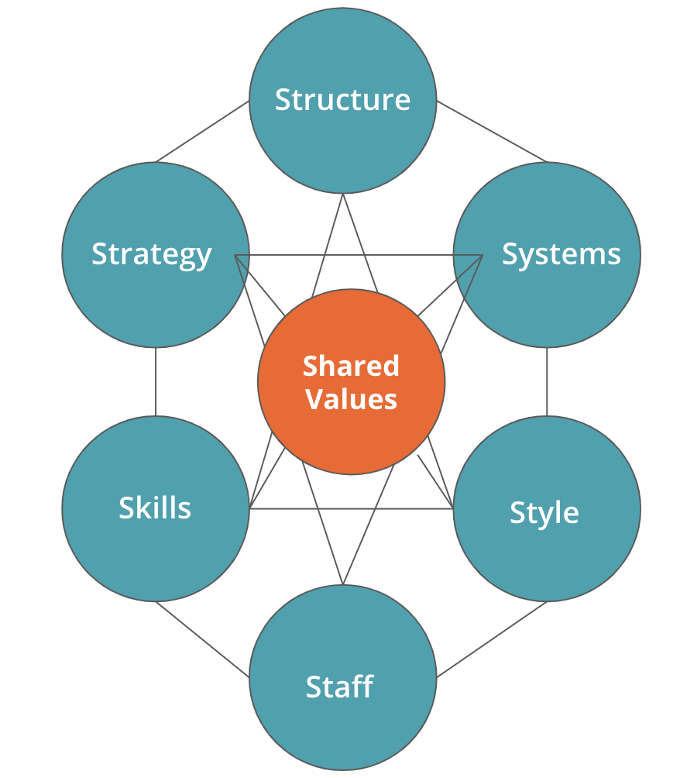

##### **Figure 2: McKinsey 7S Model**

**(Source:** Shaat *et al.* 2018**)**

This above figure has described about seven elements of McKinsey 7S Model. Those are: structure, system, style, staff, skills, strategy and shared values.

This component of ***strategy*** is one of the plans that are deployed by an organization to remain competitive in its industry and market scenario.

***Structure*** element has been involved to higher authority procedure.

On the other hand, ***shared values*** has involve to the process of norms and regulations.

***System*** has been involved to daily procedures in organizational elements.

***Skill*** is related to organizations staffs’ knowledge.

***Style*** is related to management tasks and staffs have referred to personal interface of the organization.

In this process of challenges and opportunities related to this organization this model of ***McKinsey 7S Model*** has been analyzed. In terms of mitigate the challenges of technological transfer McKinsey 7S Model has been identified and applied as organizational tool that assesses the well-being and future success of this business organization.

**Theoretical framework**

In order to implement the technology, ***Artificial Intelligence theory*** will need to be implemented in the current business environment. The major reason is that the use of AI could be evaluated by using theoretical support. Based on the available information, the ***Cloud service model*** needs to be implemented to ensure the effectiveness of Information technology which has been implemented in ***Clicktrue Group*** (Click True, 2022). Overall performances of technology could be evaluated by using the technological KPI. Hence, the success of implementing AI has been secured by AI theory. Practical implementation could not be contemplated as effective to enhance business performance without using theoretical knowledge.

# C. Detailing methodology for managing innovation and technology transfer

The objectification of the above figure has outlined the facets of specific components used in this research. It has been objectified that the idealization of the approach has been focused with a specific concept of 5-G technology innovation which has been idealized and addressed with validation of data collection and data analysis. However, it has been notified that the effectiveness of this research has been outlined with the conceptualization of the employee's responses to the specific questions. Moreover, it has been objectified that the involvement of quantitative data analysis, as well as qualitative data analysis, has been showcased in order to highlight the facets of the effectiveness of the 5-G network speed. The idealization of experimental research design has been outlined with the involvement of relationship data of cause-effect with a conceptualization of independent and dependent variables. However, it has been objectified that it has included the aspects of the survey questionnaire aligned with the facets of quantitative data collection. On the other side, the involvement of qualitative analysis has been outlined with the utilization of specific statistics for showcasing the nature and characteristics of the working environment and consumer service by means of 5-G.

# D. A reflective commentary documenting the challenge identified within the organisation and clearly evidenced with academic underpinning throughout

The utilization of both primary and secondary data collection methods has been objectified in this research which has been addressed with the objectification of specific responses of 30 participants. However, the involvement of the primary method of data collection has been scrutinized with qualitative tactics where it signifies the involvement of a specific survey of the questionnaire. Moreover, the research has also outlined the essence of secondary data collection which has been materialized with specific analysis on statistics of 5-G technology.

In conception to the specific problems, it has been objectified with the facet of limited sharing of information due to lack of high-network activities. The innovation of 5-G network communication process is idealized as communication links in terrestrial network (Guo*et al.* 2021). However, it has been notified that proliferation regarding the theft of data has been idealized as a crucial problem that does not showcase the facets of emphasis to the features of consumers' services. Digital technologies with 5-G technologies have changed the industrial and operations process of collaboration (Attaran, 2020). Moreover, it has been idealized that this conceptualization has outlined the facets of consumers' reliability in providing authentic data or payments along with the aspect of social security. However, the impact of technologies and its advancement has enhanced the facets of energy security (Paolini *et al.* 2019).

Furthermore, it has been the problems have been showcased with the time-consuming issues due to lower speed networks of the technological division of the company regarding consumer services. The essence of 5-G technology and growth leads has enhanced the facets of mobile phone industry’s by means of consumers services (Zeebaree*et al.* 2020). This conceptualization has showcased that the problem has aligned the facets of delayed responses during the live chat. The idealization of massive 5-G MIMO has a capability in boosting efficiency of the spectrum (Li *et al.* 2018). However, it has been idealized that the services asked by means of emails are objectified with the delayed conclusion which has showcased the facet of failure in responding quickly.

With reference to the context of technical problems in remote working environments, the facet of misaligned collaboration has been objectified as a fundamental challenge of the company. 5-G network technology has been idealized with industry 4.0 with an idealization of dominant digital manufacturing (Oztemel and Gursev, 2020). It has been materialized that the rate of lower interaction level has been outlined due to idealization of high-band spectrum along with the flaggy interface in the collaboration tool due to existing network activities. In conception to the following, it has been signified that due to the ineffectiveness of team collaboration, the company has faced serious issues while dealing with consumer problems.

Moreover, the problem in collaborating has showcased the continuous interruption of video conferences along with the facets of consumer services. Due to this, the importance of employee retention has been highlighted where the objectification of disruption of network activities and remote working environments are attached. However, it has been objectified that the essence of disruptive networks and remote working environments outlines the facets of less connection and collaboration of the employees between each other even. With reference to the context, it has been idealized the above-objectified problems can lead to the attributes of highly-effective attrition even there is an essence of a balanced work-life environment that can be materialized.

***Clicktrue Group*** can enhance the objectified issues of networking activities and performances by improving their bandwidth by intensifying 5-G technology which can highlight the facets of encouragement between enterprises and employees as well. However, it has been materialized that mobile access to the virtual collaboration tool can be effective for the employees as it is flexible for an uninterrupted and seamless collaboration. It has been stated as beneficial by providing the benefits of the 5-G network to the employees that have

been effective in fostering the working environment and culture digitally.

Moreover, it can be beneficial for the company to develop new concepts for employees’ collaboration. Therefore, the utilization of high-speed network activity can enhance the performance of employees with a high speed of repetitive tasks. However, the idealization of talented individuals can be objectified for 5-G networking consumer services which can be effective consumer loyalty and retention. Lower latency can be effective in advancing power AR and VR as well as loT as an enhancement of the virtual workplace environment. However, it has been notified that the initial cost structure can be a higher price with respect to the existing network activities.

# E. A section on your findings includes a critical evaluation, detailing commercially viable solutions to overcome the identified challenge

Quantitative analysis

|  |
| --- |
| ***How far do you believe that the implementation of 5-G technology can be effective in enhancing the activities of consumers' services in the company?*** |

|  |  |  |
| --- | --- | --- |
| Income level | Agree/ disagree/neutral | Responses (30) |
| Less than $5000 | agree | 7 |
| More than $5000 | agree | 15 |
| More than $10000 | disagree | 8 |

**Table 1: Questionnaire 1**

(Source: Self-made)

In conception to the above table, it has been notified that the essence of critical evaluation of 5-G technology innovation and its impact has been idealized through the responses. It has been notified from the above table that the 7 respondents have addressed their conceptions of the effectiveness of 5-G technology towards consumers services. However, the involvement of the above question has been specified with an idealization of 5-G implementation in ***Clicktrue Group***.

Moreover, the objectification of the above table has been outlined with the 15 responses related to the facet of agreeing to the implementation for accelerating consumers services. Furthermore, it has been stated the involvement of the question has been objectified with an idealization of the responses based on the income status of the employees. It has been analysed those 8 participants have addressed their opinions to the facet disagree regarding the implementation of 5-G technology.

|  |
| --- |
| ***How far do you think that the involvement of 5-G technology can increase the facets of virtual collaboration in the virtual working environment of the company?*** |

|  |  |  |
| --- | --- | --- |
| Religion | Agree/ disagree/neutral | Responses (30) |
| Jain | agree | 12 |
| Hindu | disagree | 6 |
| Christian | neutral | 12 |

**Table 2: Questionnaire 2**

(Source: Self-made)

In conception to the above table, it has been notified that the idealization of the above question has been objectified with the specific questions based on the employee's religion. However, the essence of analysis has been showcased with the conceptualization of agree, disagree, as well as neutral facets which have been signified with 12 neutral responses of the participants based on the Christian religion.

Moreover, the conceptualization of the above question has been idealized with the increasing facets of virtual collaboration by means of 5-G technology in the remote working environment which has been analysed with 12 agree on responses as a facet of positive remarks to the implementation. Therefore, the involvement of the specific data analysis has outlined the majority of agreeing with facets of the employees in ***Clicktrue Group*** towards the 5-G technology implementation.

Qualitative analysis

With reference to the objectified figure, it has been idealized that the US has been showcased with high 5-G network availability with a low-band sod spectrum of 21.4% (opensignal.com, 2022). However, it has been notified that the involvement of the above figure has been aligned with this research in order to specify the importance of this in the ***ClicktrueGroup [refer to appendix 2]***. However, the enhancement of existing technology has assisted the employees to work according to the flexibility due to the essence of high-speed services of the network. It has been objectified as a specific level of satisfaction for the employee to work easily in the WFH working environment. It has been objectified that the conceptualization of this 5-G technology has been ideally effective for the factory workers for monitoring the system performances in real-time (shrm.org, 2022).

With respect to the ethical consideration of quantitative analysis, it has been materialized that the permission from the employees has been outlined along with an idealization of avoidance to the physical as well as emotional harm. Furthermore, the ethical consideration of maintaining data security and authenticity has been addressed with a conceptualization of unbiased and neutral facets. Specific ethical considerations are being addressed in the research through qualitative data analysis which has been objectified de-identified data. However, it has idealized with the considerations of relevant content to the concept of the 5-G technology implementation. Moreover, it has been objectified that the data must not be idealized to any facets of stress and damages as well. Furthermore, the collection of data must be avoided to the groups for accessing which results in anonymous threats of confidentiality of the participant's responses.

# F. Conclusion

In this research, a critical evaluation of specific problems aligned with the company has been discussed with the objectification of 5-G technology. The section of the research has been idealized with specific aspects of networking improvements that can enhance the workplace environment. The research has concluded the analysis with primary and secondary collection of data along with the idealization of ethical consideration. However, it has been notified this research has targeted the aspects of new technology innovation for accelerating network activities align with enhancing the interface of existing network preferences.

# Reference List

***Scholars***

Abdelaziz, A. and Hamad, E.K., 2019. Design of a compact high gain microstrip patch antenna for tri-band 5 G wireless communication. *Frequenz*, *73*(1-2), pp.45-52.

Adebusola, J.A., Ariyo, A.A., Elisha, O.A., Olubunmi, A.M. and Julius, O.O., 2020, March. An Overview of 5G Technology. In 2020 International Conference in Mathematics, Computer Engineering and Computer Science (ICMCECS) (pp. 1-4). IEEE.

Aijaz, A., 2020. Private 5G: The future of industrial wireless. IEEE Industrial Electronics Magazine, 14(4), pp.136-145.

Akpan, I.J., Soopramanien, D. and Kwak, D.H., 2021. Cutting-edge technologies for small business and innovation in the era of COVID-19 global health pandemic. *Journal of Small Business & Entrepreneurship*, *33*(6), pp.607-617.

Al Attabi, K., 2019, April. Single Relay Selection in the Cognitive Cooperative Network: Toward Bandwidth Efficiency Improvement. In *2019 4th Scientific International Conference Najaf (SICN)* (pp. 222-226). IEEE.

Attaran, M., 2020, July. Digital technology enablers and their implications for supply chain management. In *Supply Chain Forum: An International Journal* (Vol. 21, No. 3, pp. 158-172). Taylor & Francis.

Bektas, C., Schüler, C., Falkenberg, R., Gorczak, P., Böcker, S. and Wietfeld, C., 2021, November. On the Benefits of Demand-based Planning and Configuration of Private 5G Networks. In 2021 IEEE Vehicular Networking Conference (VNC) (pp. 158-161). IEEE.

***Books***

Borgaonkar, R. and Jaatun, M.G., 2019, September. 5G as an Enabler for Secure IoT in the Smart Grid. In 2019 First International Conference on Societal Automation (SA) (pp. 1-7). IEEE.

Chu, H., Li, P., Zhu, X.H., Hong, H. and Guo, Y., 2019. Bandwidth improvement of center-fed series antenna array targeting for base stations in offshore 5G communications. *IEEE Access*, *7*, pp.33537-33543.

Geller, M. and Nair, P., 2018. 5G security innovation with Cisco. Whitepaper Cisco Public, pp.1-29.

Guo, Y.J., Ansari, M. and Fonseca, N.J., 2021. Circuit type multiple beamforming networks for antenna arrays in 5G and 6G terrestrial and non-terrestrial networks. *IEEE Journal of Microwaves*, *1*(3), pp.704-722.

Kaltenberger, F., Silva, A.P., Gosain, A., Wang, L. and Nguyen, T.T., 2020. OpenAirInterface: Democratizing innovation in the 5G Era. Computer Networks, 176, p.107284.

Khalili, H., Khodashenas, P.S., Fernandez, C., Guija, D., Liolis, K., Politis, C., Atkinson, G., Cahill, J., King, R., Kavanagh, M. and Jou, B.T., 2019, January. Benefits and challenges of software defined satellite-5G communication. In 2019 15th Annual Conference on Wireless On-demand Network Systems and Services (WONS) (pp. 1-4). IEEE.

Lake, D., Wang, N., Tafazolli, R. and Samuel, L., 2021. Softwarization of 5G Networks–Implications to Open Platforms and Standardizations. IEEE access, 9, pp.88902-88930.

Levin, D. and Kurtzberg, T., 2020. Sustaining employee networks in the virtual workplace. Massachusetts: MIT Sloan Management Review.

Li, Y., Luo, Y. and Yang, G., 2018. Multiband 10-antenna array for sub-6 GHz MIMO applications in 5-G smartphones. *IEEE access*, *6*, pp.28041-28053.

Morocho-Cayamcela, M.E., Lee, H. and Lim, W., 2019. Machine learning for 5G/B5G mobile and wireless communications: Potential, limitations, and future directions. IEEE Access, 7, pp.137184-137206.

Oztemel, E. and Gursev, S., 2020. Literature review of Industry 4.0 and related technologies. *Journal of Intelligent Manufacturing*, *31*(1), pp.127-182.

Paolini, V., Petracchini, F., Segreto, M., Tomassetti, L., Naja, N. and Cecinato, A., 2018. Environmental impact of biogas: A short review of current knowledge. *Journal of Environmental Science and Health, Part A*, *53*(10), pp.899-906.

Russell, C.L., 2018. 5 G wireless telecommunications expansion: Public health and environmental implications. *Environmental research*, *165*, pp.484-495.

Salih, A.A., Zeebaree, S.R., Abdulraheem, A.S., Zebari, R.R., Sadeeq, M.A. and Ahmed, O.M., 2020. Evolution of mobile wireless communication to 5G revolution. Technology Reports of Kansai University, 62(5), pp.2139-2151.

Salih, A.A., Zeebaree, S.R., Abdulraheem, A.S., Zebari, R.R., Sadeeq, M.A. and Ahmed, O.M., 2020. Evolution of mobile wireless communication to 5G revolution. *Technology Reports of Kansai University*, *62*(5), pp.2139-2151.

Shaat, M., Lagunas, E., Perez-Neira, A.I. and Chatzinotas, S., 2018. Integrated terrestrial-satellite wireless backhauling: Resource management and benefits for 5G. ieee vehicular technology magazine, 13(3), pp.39-47.

Tian, M.W., Wang, L., Yan, S.R., Tian, X.X., Liu, Z.Q. and Rodrigues, J.J.P., 2019. Research on financial technology innovation and application based on 5G network. IEEE Access, 7, pp.138614-138623.

Usharani, S., Jayakumar, D., Palani, D.U., Raghuraman, D., Parthiban, R., Saravanan, D. and David, D.D.S., 2020. Industrialized service innovation platform based on 5g network and machine learning. European Journal of Molecular & Clinical Medicine, 7(11), pp.5684-5703.

Yıldız, A., Džakmić, Š. and Saleh, M.A.J.S.E., 2019. A short survey on next generation 5G wireless networks. Sustainable Engineering and Innovation, 1(1), pp.57-66.

***Websites***

Click True, 2022 *Inbound Marketing Tailored For Businesses With Long Sales Cycle.* Available at: https://page.clicktrue.biz/ [Accessed on: 5th March, 2022]

Open signal, 2022 *Benchmarking the global 5G user experience – October update.* Available at: https://www.opensignal.com/2020/10/13/benchmarking-the-global-5g-user-experience-october-update [Accessed on: 5th March, 2022]

Qualcomm, 2022 *Everything you need to know about 5G.* Available at: https://www.qualcomm.com/5g/what-is-5g#:~:text=5G%20wireless%20technology%20is%20meant,experiences%20and%20connects%20new%20industries. [Accessed on: 5th March, 2022]

SHRM, 2022 *How 5G Will Reshape Work.* Available at: https://www.shrm.org/hr-today/news/all-things-work/pages/how-5g-will-reshape-work.aspx [Accessed on: 5th March, 2022]

# Appendices

## Appendix 1: 5-G architecture

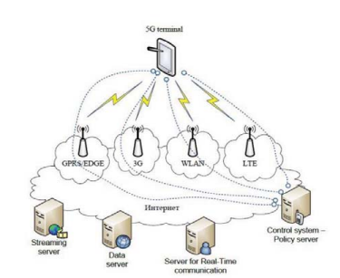

## Appendix 2: Connectivity rate of the 5-G network across the world

